Wind power forecasting based on daily wind speed data using machine learning algorithms
Indicator | Details
Objective | - To forecast the generated wind power with respect to daily wind speed data  - To test eligibility of the generated wind power forecasting model for one location to be used in other locations
Y | year-ahead wind power generation  (note: wind power generation for the training set is calculated based on a equation)
x | - Daily wind speed (converted from hourly wind speed)  - Daily standard deviation of hourly wind speed
Data span | 5 years: 4 years for training, 1 year for testing
Algorithms used | - LASSO  - kNN  - XGBoost  - RF  - SVR
Training | The machine learning algorithms were trained on 4 years of daily mean wind speed, standard deviation, and the daily total wind power and final one year were forecasted  Split: 80% (4 years), 20% (1 year)
Validation / CV | No
Metric | R-squared, MAE, RMSE
Results | 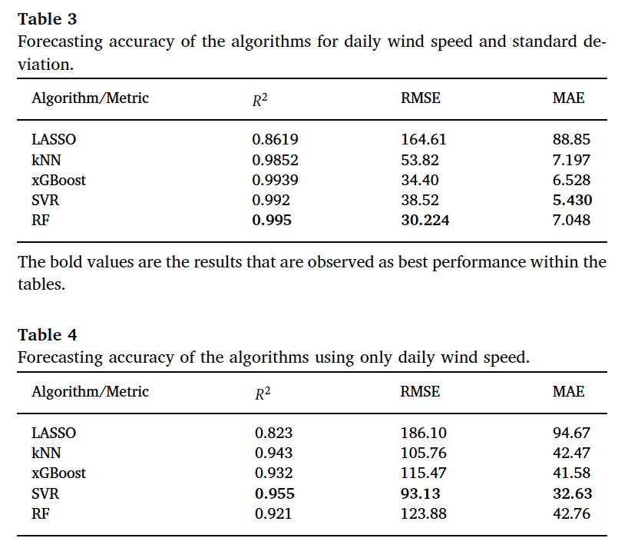
Contributions | To better demonstrate the efficiency of our proposed machine learning based wind power forecasting models, authors tested the models against the wind speed values of four different locations
A Machine Learning-Based Gradient Boosting Regression Approach for Wind Power Production Forecasting: A Step towards Smart Grid Environments
Indicator | Details
Objective | - Test various machine learning methods to forecast wind power based on wind speed and wind direction data
Y | Produced power (10min granularity for both training and test samples collected 1 wind farm in Turkey)
x | - Wind speed  - Wind direction  - Theoretical wind power
Data span | 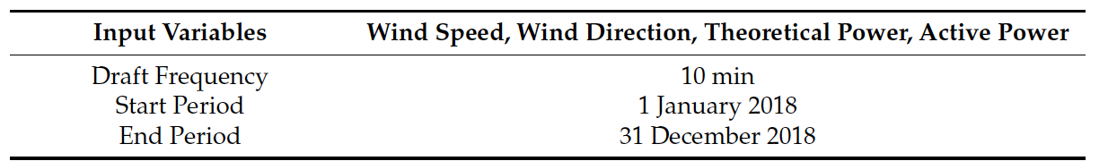
Algorithms used | - RF  - kNN  - GBM  - Decision tree  - Extra tree
Training | the dataset, i.e., 47,033 data points, were considered for implementing the machine learning models  Split: training (70%), test (30%)
Validation / CV | No
Metric | R-squared, MAE, MPE, RMSE, MSE
Results | 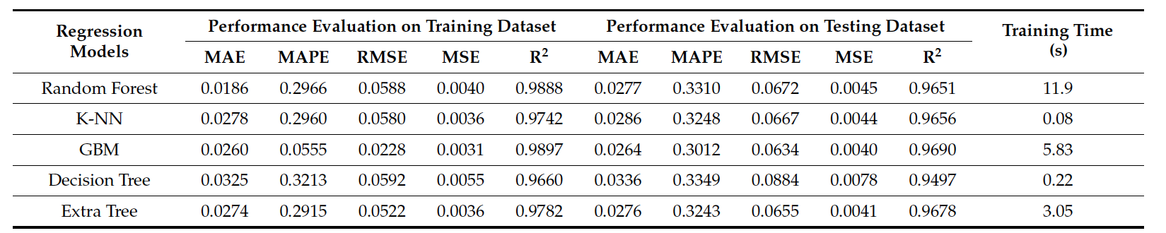
Contributions | Short-term wind power forecasting on the basis of the historical values of wind speed, wind direction, and wind power by using  ML algorithms

Efficient Wind Power Prediction Using Machine Learning Methods: A Comparative Study
Indicator | Details
Objective | Demonstrate greater efficiency of ML algorithms other static algorithms
Y | Wind power production
x | - Wind direction  - Wind speed
Data span | For France data, the investigated models are trained using data recorded from 1 February 2017 to 30 June 2017.  For the Turkey data, the train data are collected from 1 February 2018 to 30 June 2018.  Kaggle data contain some significant periods with missing values, which are discarded. We considered only periods with a few missing values. Specifically, we selected data for training from 1 January 2020 to 30 March 2020.
Algorithms used | Listed in Results
Training | We took the next three days of each training dataset for testing (i.e., 432 data points).
Validation / CV | 5-fold cross-validation procedure is adopted in training to avoid overfitting
Metric | R-squared, MAE, RMSE
Results | 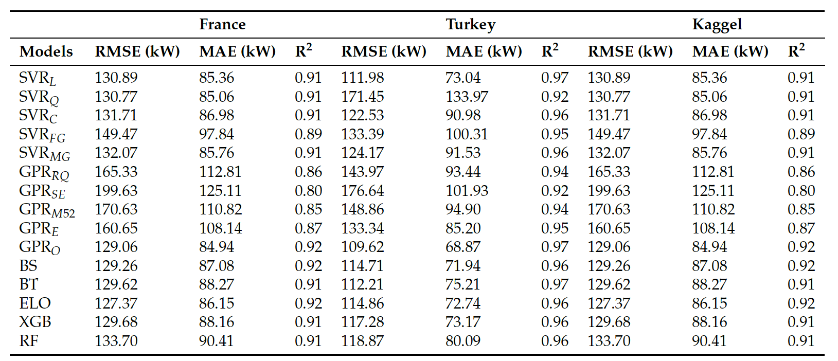
Contributions | This study first applied and compared several machine learning approaches to model the nonlinear wind power dynamics and forecast the future trends of wind power.

